Name: Jarosław Rybak

Class: CS 331

Project: 4

Creation



Note: Where it says that user can view all, it is the normal state so SySDBA account might as well be the one. As it is important to display an understanding to creat users with limited access.

Q1

Selected users of the database are restricted from accessing student address, date

of birth, age and email. Other users of the database have the ability to view all

columns in the student table. Create SQL to implement. Login with the new

security enabled accounts and demonstrate your implementation will only display

the requested columns.

As SysDBA;

**CREATE USER NonAdmin IDENTIFIED BY "password1";**

**GRANT CREATE SESSION to NonAdmin;**

**Create view Students_Name_View as**

**select STUDENT_ID,STUDENT_FIRST,STUDENT_LAST**

**from students;**

**Grant SELECT on Students_Name_View TO nonadmin;**

As NonAdmin

**SELECT * FROM sys.Students_Name_View;**



Q2

Student consent forms can be viewed, but not deleted. Create SQL to implement.

Login with the new security enabled accounts and demonstrate your

implementation will view only and not delete consent forms.

As SysDBA

**GRANT SELECT on consent_form to nonadmin;**

As NonAdmin

**SELECT * FROM sys.consent_form;**

**DELETE from sys.consent_form**

**WHERE form_id = '1001';**





Q3

Selected NYC Department of Education staff can display all vaccine status

columns. Other users can only view a subset of these columns. Create SQL to

implement. Login with the new security enabled accounts and demonstrate your

implementation will only display the requested columns.

Ran into a bit a problem since I made a different table for students and staff, so i had to come up with the solution just making 2 grants.

**CREATE VIEW Students_Vacc_Limit as**

**SELECT STUDENT_ID,VACC_BRAND**

**From vaccine_sudents;**

**CREATE VIEW Staff_Vacc_Limit as**

**SELECT STAFF_ID,VACC_BRAND**

**From vaccine_staff;**

**GRANT SELECT on Students_Vacc_Limit to nonadmin;**

**GRANT SELECT on Staff_Vacc_Limit to nonadmin;**

As NonAdmin

**SELECT \***

**FROM sys.Students_Vacc_Limit;**

**SELECT * FROM sys.Staff_Vacc_Limit;**



Q4

Selected NYC Department of Education staff can change the vaccine status fields.

Other users can only view and not change these columns. Login with the new

security enabled accounts and demonstrate your implementation will allow

editing of selected fields for only staff.

Since it says columns i am assuimg alter table and not update rows.

**CREATE USER CanDo IDENTIFIED BY "CanPassword";**

**CREATE USER CanNotDo IDENTIFIED BY "NotPassword";**

**GRANT CREATE SESSION to CanDo;**

**GRANT CREATE SESSION to CanNotDo;**

**Grant SELECT on vaccine_staff to CanDo;**

**Grant SELECT on vaccine_staff to CanNotDo;**

**Grant ALTER on vaccine_staff to CanDo;**

As CanNotDo

**SELECT \***

**From sys.vaccine_staff;**



**ALTER table sys.vaccine_staff**

**add ExtraColumn number(2);**



As CanDo

**ALTER table sys.vaccine_staff**

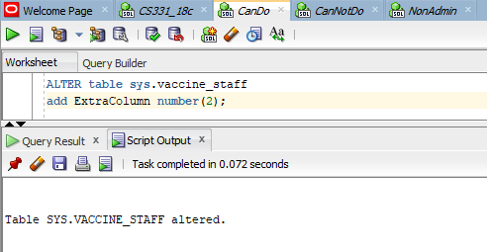**add ExtraColumn number(2);**



Q5

The guardians for student Joe Smith provided consent to perform weekly testing 4

times and revoked consent 3 times. Identify the SQL to implement.

**INSERT INTO students(student_id, student_first, STUDENT_LAST, STUDENT_STATE, STUDENT_CITY, STUDENT_ZIP)**

**VALUES ('701', 'Joe', 'Smith', 'NJ', 'Newark', '14513');**

**INSERT INTO consent_form(FORM_ID, STUDENT_ID, CONSENT_TYPE, CONSENT_DATE)**

**WITH NewInsert AS (**

**SELECT '7101', '701', 'Authorized', to_date('2021-12-12','YYYY-MM-DD') FROM dual UNION ALL**

**SELECT '7102', '701', 'Revoked', to_date('2021-12-13','YYYY-MM-DD') FROM dual UNION ALL**

**SELECT '7103', '701', 'Revoked', to_date('2021-12-14','YYYY-MM-DD') FROM dual UNION ALL**

**SELECT '7104', '701', 'Revoked', to_date('2021-12-15','YYYY-MM-DD') FROM dual UNION ALL**

**SELECT '7105', '701', 'Authorized', to_date('2021-12-16','YYYY-MM-DD') FROM dual UNION ALL**

**SELECT '7106', '701', 'Revoked', to_date('2021-12-17','YYYY-MM-DD') FROM dual UNION ALL**

**SELECT '7107', '701', 'Authorized', to_date('2021-12-18','YYYY-MM-DD') FROM dual**

**) SELECT * FROM NewInsert;**



Q6

In one SQL window, delete all consent forms provided in the last month at 1

school. Don’t commit. In another SQL window, add 5 new consent forms. Don’t

commit. In each SQL window, identify the number of consent forms. Explain

your results. Show all SQL to perform these operations. Demonstrate the

functionally of your SQL by displaying the before and after results.

**grant SELECT on consent_form to nonadmin;**

**Grant SELECT on consent_form to CanDo;**

**grant UPDATE on consent_form to nonadmin;**

**Grant UPDATE on consent_form to CanDo;**

**grant DELETE on consent_form to nonadmin;**

**Grant DELETE on consent_form to CanDo;**

**grant INSERT on consent_form to nonadmin;**

**Grant INSERT on consent_form to CanDo;**

As NonAdmin

**DELETE from sys.consent_form**

**WHERE consent_date BETWEEN date'2021-11-22' and date'2021-12-22';**

As CanDo

**INSERT INTO sys.consent_form(FORM_ID, STUDENT_ID, CONSENT_TYPE, CONSENT_DATE)**

**WITH NewInsert AS (**

**SELECT '7108', '701', 'Authorized', to_date('2021-12-19','YYYY-MM-DD') FROM dual UNION ALL**

**SELECT '7109', '701', 'Revoked', to_date('2021-12-20','YYYY-MM-DD') FROM dual UNION ALL**

**SELECT '7110', '701', 'Revoked', to_date('2021-12-21','YYYY-MM-DD') FROM dual UNION ALL**

**SELECT '7111', '701', 'Revoked', to_date('2021-12-22','YYYY-MM-DD') FROM dual UNION ALL**

**SELECT '7112', '701', 'Authorized', to_date('2021-12-23','YYYY-MM-DD') FROM dual**

**) SELECT * FROM NewInsert;**

As NonAdmin

**SELECT count(Form_ID)**

**from SYS.consent_form;**



As CanDo

**SELECT count(Form_ID)**

**from SYS.consent_form;**



Q7

In one SQL window, delete all staff at 1 school. Don’t commit. In another SQL

window, delete staff at all schools. Don’t commit. Explain your results. Resolve

the problem. Create a backup of your table before implementing. To create a

backup table, enter CREATE TABLE <NEWTABLE> AS SELECT * FROM

<ORIGINALTABLE>; COMMIT; Then you can rename a table using the

RENAME TABLE commit. Disable the auto commit flag at the top of the

window before performing this operation. Show all SQL to perform these

operations. Demonstrate the functionally of your SQL by displaying the before

and after results.

Before evem starting i can say the issue is going to be that the that Staff.Staff_ID is a PK in 2 other tables. If i make a copy and delete from the copy it should be fine.

**CREATE TABLE Staff_Copy AS SELECT * FROM**

**staff;**

**commit;**

As NonAdmin

No difference between 1 staff, all staff ata chool, or all staff in this case.

You can not do it because of the FK constraint.

I would have to delete the rows in the other tables first.

**DELETE FROM sys.staff**

**WHERE staff_id = '2201';**



Now to Staff2

**Rename staff to staff2;**

As NonAdmin

Same as Last Time, reason being is that when i rename it the FK constraints get automaticly updated by SQL Dev or Orcale, i think it's Oracle doing it, so i may have changed the name but the connections and constraints are still the same. This is what i expected.

**DELETE FROM sys.staff2**

**WHERE staff_id = '2201';**

Q8

In one SQL window, change the last name for the student Joe Smith. Don’t commit.

In another SQL window, change the address of student Joe Smith (use the same name

as above). Don’t commit. Quit both Oracle sessions. Login to Oracle again and

display all columns for the customer Joe Smith . Explain your results. Disable the

auto commit flag at the top of the windows before performing this operation.

Show all SQL to perform these operations. Demonstrate the functionally of your

SQL by displaying the before and after results.

AS SYSDBA

**grant SELECT,UPDATE on students to nonadmin;**

**Grant SELECT,UPDATE on students to CanDo;**

Before

AS NonAdmin

**UPDATE SYS.students**

**set student_last = 'Carpenter'**

**Where student_first = 'Joe' and student_last = 'Smith';**



AS CanDo

**UPDATE SYS.students**

**set STUDENT_STATE = 'TX', STUDENT_CITY = 'Austin', STUDENT_ZIP = '73301'**

**Where student_first = 'Joe' and student_last = 'Smith';**

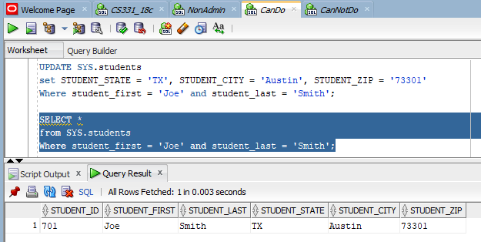

After

AS CanDo

**SELECT \***

**From SYS.students**

**Where student_first = 'Joe' and student_last = 'Smith';**



As NonAdmin

**SELECT \***

**From SYS.students**

**Where student_first = 'Joe' and student_last = 'Smith';**

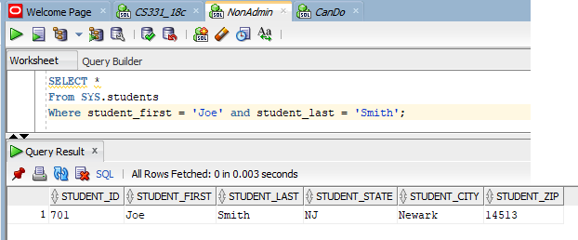

Explain

The reason that the changes were not saved is because I did not commit the changes as specified in the Question.

Q9

Use the SQL DESCRIBE operation to display the structure for all tables.

**DESC students;**

**DESC guardians;**

**DESC schools;**

**DESC staff;**

**DESC vaccine_sudents;**

**DESC vaccine_staff;**

**DESC consent_form;**

**DESC students_guardians;**

**DESC students_schools;**

**desc staff_schools;**

**Name Null? Type**

**------------- -------- ------------**

**STUDENT_ID NOT NULL VARCHAR2(11)**

**STUDENT_FIRST VARCHAR2(20)**

**STUDENT_LAST VARCHAR2(20)**

**STUDENT_STATE VARCHAR2(2)**

**STUDENT_CITY VARCHAR2(20)**

**STUDENT_ZIP CHAR(5)**

**Name Null? Type**

**-------------- -------- ------------**

**GUARDIAN_ID NOT NULL VARCHAR2(11)**

**GUARDIAN_FIRST VARCHAR2(20)**

**GUARDIAN_LAST VARCHAR2(20)**

**GUARDIAN_PHONE VARCHAR2(11)**

**GUARDIAN_EMAIL VARCHAR2(35)**

**Name Null? Type**

**--------------- -------- ------------**

**SCHOOL_ID NOT NULL VARCHAR2(11)**

**SCHOOL_NAME VARCHAR2(35)**

**SCHOOL_STATE VARCHAR2(2)**

**SCHOOL_CITY VARCHAR2(20)**

**SCHOOL_ZIP CHAR(5)**

**SCHOOL_BOROUGH VARCHAR2(15)**

**SCHOOL_DISTRICT NUMBER(5)**

**ERROR:**

**ORA-04043: object staff does not exist**

**Name Null? Type**

**---------- -------- ------------**

**VACC_ID NOT NULL VARCHAR2(11)**

**STUDENT_ID VARCHAR2(11)**

**VACC_BRAND VARCHAR2(20)**

**VACC_FIRST NOT NULL NUMBER(1)**

**VACC_LAST NOT NULL NUMBER(1)**

**Name Null? Type**

**----------- -------- ------------**

**VACC_ID NOT NULL VARCHAR2(11)**

**STAFF_ID VARCHAR2(11)**

**VACC_BRAND VARCHAR2(20)**

**VACC_FIRST NOT NULL NUMBER(1)**

**VACC_LAST NOT NULL NUMBER(1)**

**EXTRACOLUMN NUMBER(2)**

**Name Null? Type**

**------------ -------- ------------**

**STUDENT_ID VARCHAR2(11)**

**CONSENT_TYPE NOT NULL VARCHAR2(10)**

**CONSENT_DATE DATE**

**FORM_ID NOT NULL VARCHAR2(11)**

**Name Null? Type**

**----------- -------- ------------**

**STUDENT_ID NOT NULL VARCHAR2(11)**

**GUARDIAN_ID NOT NULL VARCHAR2(11)**

**Name Null? Type**

**---------- -------- ------------**

**STUDENT_ID NOT NULL VARCHAR2(11)**

**SCHOOL_ID NOT NULL VARCHAR2(11)**

**ENROLLMENT DATE**

**STATUS NOT NULL NUMBER(1)**

**Name Null? Type**

**--------- -------- ------------**

**STAFF_ID NOT NULL VARCHAR2(11)**

**SCHOOL_ID NOT NULL VARCHAR2(11)**

Q10

Display the version of Oracle



Non Class Extra

I wanted to give this in to you by the end of the 21st but I had be a gofer yesterday.

On a related note here is our Christmas tree, Merry Christmas!

